LI–RT-PCR: Gradient Thermal Cycler – touch screen

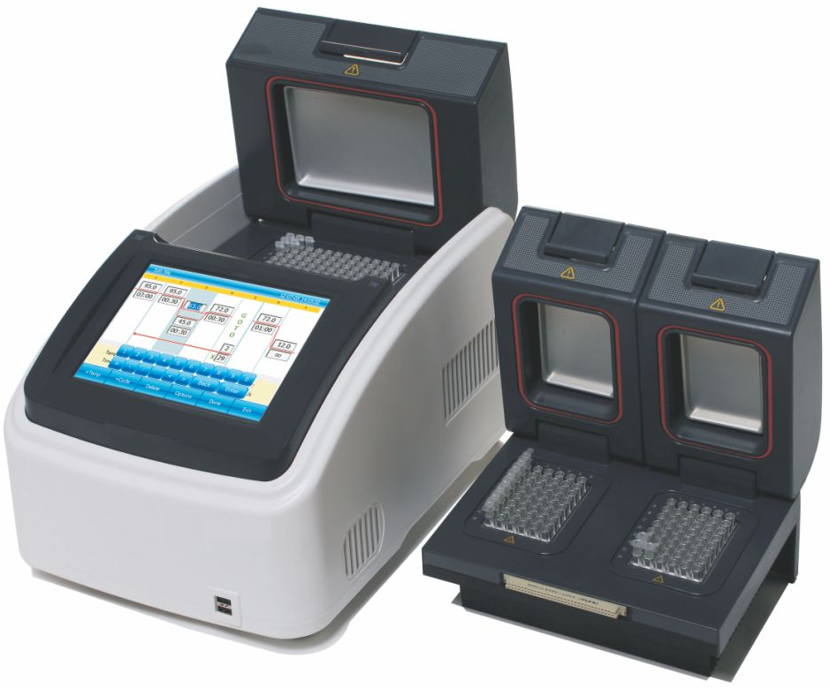

SALIENT FEATURES :

  - Advanced technologies, WINDOWS operating system.
  - Automatic restart after power failure.
  - Each thermal block has 4 independent temperature control sensors and 8 pettier heating units to ensure accurate and uniform temperature across block surface, and provide users with replicating previous condition set-up.
  - 8" TFT colour touch-screen with graphical display provides easy use for setting up and monitoring set parameter.
  - The actual and target temperatures can be viewed and displayed graphically in real time.
  - Built-in 11 standard program file template, can quickly edit the required files.
  - Internal flash memory for 10000 typical PCR files in free configurable folders.
  - Compatible with mouse, keyboard, capable to transfer data and perform software updates via USB Drive.
  - Applicable with the following 0.2m1 tube models: non-skirted, semi and fully skirted plated.
  - Replaceable module, dual-block module can simultaneously run two different PCR programs.

PRODUCT DETAILS :

Polymerase Chain Reaction (PCR) is widely used in Molecular biology. As PCR progresses, the DNA thus generated is used as template for replication. With PCR it is possible to amplify a single or few copies of a specific DNA fragment across several orders of magnitude, generating millions copies of the DNA fragments.

SPECIFICATIONS :

 | Make | LABARD
 | Model | LI-RT-PCR
 | Capacity | 96 X 0.2ml
 | Temperature Range | 0 - 100°C
 | Max. Heating Rate | 5°C/s
 | Max. Cooling Rate | 4°C/s
 | Uniformity & Accuracy | ±0.1°C
 | Display Resolution | 0.1 "C
 | Temperature Control | Block Tube
 | Ramping Rate Adjustable | 0.1 ~ 5°C
 | Gradient Uniformity | ±0.2°C
 | Gradient Accuracy | ±0.2°C
 | Gradient Temp. Range | 30 - 100°C
 | Gradient Spread | 1 ~ 30°C
 | Hot Lid Temperature | 30 ~ 110"C
 | Hot Lid Height Adjustable | Sleepless adjustable
 | Number of Programs | 10000 +(USB FLASH)
 | Max. No. of Step | 30
 | Max. No. of Cycle | 99
 | Time Increment/Decrement | Sec - 9 Min 59 Sec Yes
 | Temp. Increment / Decrement | 0.1 - 93°C Yes
 | Pause Function | YES
 | Auto Data Protection | YES
 | Hold at 4"C | Forever
 | Print, LAN to computer, | YES
 | LCD display | Touch Screen, 8inch , 800x600 Pixels, TFT
 | Communication | USB2.0 , LAN
 | Power Supply | 85 - 264VAC , 47 ~ 63Hz , 600 W
 | Dimension (L*W*H) | 380 X 240 x 260 mm
 | Weight | 9kg

